BRINGING A CHURCH INTO THE DIGITAL AGE

By FELICIA TAYLOR

A THESIS PRESENTED IN PARTIAL FULFILLMENT OF THE REQUIREMENTS

FOR THE DEGREE OF MASTER OF ARTS IN PUBLIC RELATIONS

FULL SAIL UNIVERSITY

2020

**Table Of Contents**

Acknowledgements…………………………………..…………………………………………...3

Executive Summary………………...…………………..……………………………………...…4

Situation Analysis………………………………………..………………………..…………..….5

Research Plan…………………………………………..………………………………….….....10

Campaign Plan………………………………………..………………………..………………..18

References……………………………………………..…………………….………………..…24

Appendix A: Press Releases……………………………………………………….…………….28

Appendix B: Media List……..……………………………………………………….………….29

Appendix C: Media Kit……...……………………………………………………….………….30

Appendix D: Infographics……...…….………………………..…………………….…………..31

Appendix E: Twitter Account Analytics …...……………………………...………………..…..32

Appendix F: Event Flyer…...……………………………...………………………….…………33

**Acknowledgements**

I would like to thank God for giving me the strength and patience to be able to completed my program, my late mother, older brother, and grandma, I know that they are watching over me and proud of me. My dad for putting up with my ranting about research and a certain person who would not listen to me for the longest time; even when he had no idea what I was talking about. My boyfriend who has been patient and encouraging, and who pushed me when I needed it most. I want to thank all my professors, but especially, Ginger Palmisano, Christy Foley, and Dr. Diane Dobry, for putting up with my overthinking, encouraging me, and patiently answering any and all questions I had. And lastly, I would like to thank my streaming community. They were also very encouraging and extremely patient when I would just get stressed and vanish from streams for days at a time; when I came back, they all showed back up like I never missed a day. Thank you to all of these wonderful people.

**Executive Summary**

The client is South Memorial Christian Church, owned by preacher Mark Valadez. The church focuses on bringing the word of God to the community. They also focus on giving back to the community through free services, like help paying for bills and giving food, to those in need. The goals for the campaign included: increasing church membership among a certain demographic, building up their social media presence, building a website, and to start livestreaming and podcast services. The campaign was made to boost the church into the digital age and, ideally, the campaign would make it easier for people to attend the church; being able to watch and/or listen at work or at home. The results of the campaign were varied as due to COVID-19, not all the goals were possible to accomplish. The church’s social media profiles were made and utilized bringing in more engagement and making others aware of the church itself. The website is still a work in progress, as is the livestreaming and podcasts services.

**Situation Analysis**

**Company Overview**

Mark Valadez is the owner and pastor of South Memorial Christian Church, which is located at 8411 South Flores Street. in San Antonio, Texas. The church has been around for about 57 years with the original owner and pastor retiring at the end of 2018. The church first began in a small one-story building and has since been able to move into a bigger, three-story building to hold their members, as well as equipment. The church also offers various services, with the main one being, of course, bringing people the word of God. Other services they offer are helping those in need with bills, food, shelter, counseling with a trained professional, and other services provided to the community in general; for example, funerals and weddings.

The church has done little in the way of any type of communications. Their image and reputation are based solely on what members and other people in attendance think. The only public relations campaign done by the church has been word-of-mouth communication and the occasional passing out of business cards. Along with this, the only social media the church has is an official [Facebook](https://www.facebook.com/pages/category/Religious-Center/South-Memorial-Christian-Church-120869907928384/) page, though under the old leadership it was not utilized at all. The church was not very interested in any public relations approaches or changing their strategy, in this case, word-of-mouth communication, at all. Adding all this together, the lack of social media presence, the lack of a real public relations strategy, and the lack reputation within the community, the church’s strategy has been extremely ineffective.

**Competitive Analysis**

There are many types of religions that are competing with each other every day, even if indirectly. Under the banner of Christianity there are sub-religions, such as: Baptist, Catholicism, Protestants, even just Non-Denominational. One of the primary leaders of the social media movement among churches is Crossroads Church, which is Baptist. This church is growing and opening more churches across the nation, and they have a whole team solely dedicated to public relations and social media.

Even though the client’s church is non-denominational, he is still competing indirectly with Crossroads, even if they are not in the area. They could open a church at any time or people may simply go to their website and/or church application and watch livestream presentations of the sermons being given. There is only one other non-denominational church that serves as their main competition. However, at the same time it is not a direct competitor as it is a Spanish-speaking church only, while the client’s church is an English-speaking only.

This competitor does have translators on staff for those not fluent in Spanish. Other than that, and the traditional sermons the church gives, they do not have any other services or products that are similar to what the client offers.

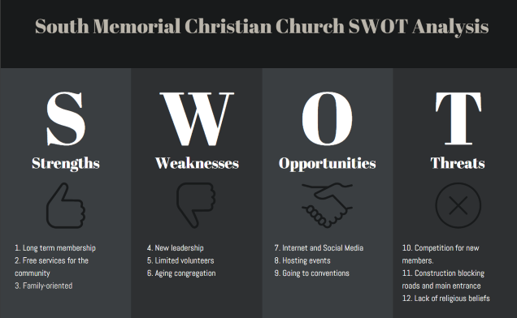**SWOT Analysis**

SWOT Analysismade with Venngage (<https://infograph.venngage.com>)

***Strengths***

After speaking with members of the church, many have been there since the church first opened 57 years ago, showing loyalty to the church itself. The church also offers many different services to the community for free, such as: shelter, help with bills, food, and counseling. All without expecting anything in return. The church is family-oriented having various learning classes for each age group, from kinder to adults.

***Weakness***

In the past, the leadership of the church has changed. This can be seen as a weakness because the members were used to one leadership style, and with a younger pastor and owner the style is changing. Currently there are only a handful of volunteers who help with the upkeep of the church as well as any events the church hosts. As such, many are starting to feel tired and burnt out with these efforts. Another glaring weakness is the fact that since many members have been there from the beginning, they are aging. Under the old leadership style many of the younger members ended up leaving to find another church or just leaving churches altogether.

***Opportunities***

Thanks to the internet and social media, there is a chance to reclaim and gain new members. As researched, millennials rely heavily on social media, they use it to keep up with any and all news. They use it to share interesting posts and they use it to watch and/or listen to others while in various places, even across the globe (AdParlor, n.d.-a). A great chance for the church to be able to reach out to the community is to continue to host events, but open it to the public. For example, the church has a Valentine’s Day event, but only for the members of the church. Opening such events to the public is an opportunity to let the community see what the church is about in a fun, less formal way.

Another opportunity is going to conventions. There are some conventions that are willing to give up a free space or a space at a reduced cost to non-profit organizations. There are even some church members, the pastor included, who enjoy going to various conventions. This could also be a chance to network with other groups and pass out fun trinkets to people to garner interest.

***Threats***

There are many competitors out there for churches. Churches can go against others of the same faith or compete with others of different faiths. Millennials are more open to jumping around religions until they find what they are looking for. This means that they can be Baptist and then turn around and start practicing the Mormon faith.

An outside threat that cannot be helped is construction. Although there is generally no construction work on Sundays; crews will often leave their equipment there and in some cases leave the roads blocked for when they come back on Monday. This is the case for the client’s church, as due to construction their main entrance is blocked. This is a problem, as those who may be trying to visit will not know about or how to get to the second entrance and they may leave. This can cause frustration, and the visitors may not want to go back again.

One of the biggest threats, however, comes from a lack of religious beliefs. Many millennials have had enough of organized religions, but are spiritual. They still believe in God, but are looking for more than an answer to, “Where do we go when we die?” than the basic heaven and hell or a nice sugar-coated answer. In addition to this, they do not want the traditional conversation of “Let’s sit and talk in my office.” They are looking for more open space. Millennials are doing yoga and meditating as a way to focus more on spirituality than religion as a whole (Frainey, 2017).

**Research Plan**

**Secondary Research Report**

The demographics of millennials are diverse. It first starts with the age range; millennials in 2018 ranged from 22-to-37 years old. According to Bialik and Fry (2019), about 39% of millennials have a bachelor’s degree or higher. Not only that, but more women are getting their degrees and starting careers than ever before. Millennials are also less likely to own a home due to the high cost of buying, but low cost of pay in their jobs.

Another demographic to pay attention to is the marital status. Most, if not all, millennials are not in a rush to get married, have children, or even move out of their parents’ house. Most attribute this to be due to the nature of instability of the economy and needing to work harder and longer just to survive (Frey, n.d.). This is important to know as it shows that millennials want a church that is willing to help them when needed, that understands when they cannot give tithe, and know that they church genuinely cares about them (Braff, 2018).

Kolomatsky (2020) states that the majority of millennials can be found in various states, the most popular ones being California, Texas, Colorado, North Carolina, Washington, Utah, Michigan, and Tennessee. Breaking that down further, some of the top cities are Austin, Denver, Salt Lake City, and San Jose. It is important that businesses, churches included, know where their target market is or where they are trying to go. Millennials have a habit of jumping around. They are constantly looking for better opportunities, whether that is for a job, for school, or even for an overall better environment, which includes churches, too (Adkins, n.d.). It is for this reason that churches, especially ones looking to draw in millennials, need to be aware of which states will draw them in; otherwise, it could be considered a waste of time to try to draw them in only for them to leave and leave the church in limbo.

Millennials are heavily into social media, and with that comes the need for creativity; they do not want to see the same boring advertisements or traditional marketing that their parents or grandparents are used to. Adparlor (n.d.-b) shows that millennials can be found using many different social media platforms; some have one or two, some have all of them. One important takeaway from this, however, is that millennials are not necessarily using social media to keep in touch with friends and family like older generations.

Millennials are using social media to follow celebrities and influencers. They are using it to follow brands, companies, and even streamers; whether that be gaming channels, music channels, or artist channels. In order to keep up with millennials companies must embrace social media and learn new and creative ways to grab their attention; and this is true for the church as well.

The consumers are a little bit different when it comes to the client’s industry compared to other industries, as it is a church. But one thing that every industry has in common is the desire to be able to communicate with their consumers and vice versa. Industries want to be able to match what their consumers want and what is familiar to them. If the consumers use Twitter to share and retweet things, they want to be able to find the church’s page and share and retweet things from there, as well.

Millennials prefer using applications; everything has an application in today’s society and if it does not, they find it to be strange or old fashioned. They want to be able to communicate through applications, as well. They want to be able to tell you what they like and do not like about things. They want to be able to get the quick updates, and after just a glance, they are moving on (Clement, 2019). Good companies will ask meaningful questions that they genuinely want to hear the answer for. And, consumers are the same. They want to feel as if the questions, comments, or answers they receive are like a one-on-one conversation.

Reviews are another huge takeaway in today’s society. Most people, before going to eat, to see a movie, to buy a video game, look at reviews. What do other people have to say about this product or service? Churches are not immune to this either. People may be looking to go to church for the first time, looking to go to try something new, or maybe they just moved and have to start over.

And there are plenty of questions they want to try and get answered by looking through reviews. Are they a mixed congregation or are they predominately one race? How are the services? Is the church mostly focused on trying to get money? Do they work with the community? Is there more than just one option as far as services go? What does the church expect from me? (Barna Group 2015-a).

These are some big questions and they may or may not find them all on reviews, but if even just one is answered it gives the consumer a starting point. If the church has social media and a website, even better. It allows them to contact the church directly or see what it is really about before going.

**Primary Research Design**

***Introduction***

Many churches are struggling, not only within their own communities, but also with membership. Millennials now make up the majority of today’s society, and with that comes the heavy use of social media (SmartInsights, 2020). Companies are having to get creative, not only in order to draw them in, but to have them purchase their products or even donate time and money to a cause. This again can be attributed to the instability of the economy and, therefore, millennials not wanting to spend if they do not have to or are neither interested nor invested in the product and/or cause (Barna Group, 2015-b).

This is where surveys and focus groups come into play. In one survey millennials were asked “why they do or don’t think church is important…” (Barna Group, 2015, research, closed doors para. 2) or that they have a “general feeling that church is simply not necessary…” (Barna Group, 2015, research, closed doors para. 5). There were varying causes to this answer that tie back into earlier research conducted, two of which were that they found it boring (31%) and “outdated” (8%).

As stated by The Gallup Organization (2007), “Polls tell us what proportion of a population has a specific viewpoint…” (para. 2) There are several ways to poll people, one of the most popular options is still the face-to-face surveys. But again, in a digital age, companies need to be able to reach more people, and they can easily do this by creating a straw poll. It is online and easily sent to people or posted on social media for, not only followers to take, but with the right keywords attached to it, others not following can find and take the poll, as well.

Another good way to find out what people want and what they are open to is to talk to the members already present. This is where the concept of a focus group comes into play. “…it pays to listen. Everyone knows the value of one-on-one conversations, yet it might not always be the most efficient use of time for a busy leader.” (Horrell, 2019, para. 1) With the focus group, a series of questions were asked to a group of about ten members. Depending on what the questions entail, for example, the type of sermons given, the pastor should be there. If it is a question about the music, the music leader should be there, and so on.

A focus group was gathered and asked several questions regarding the changes the church is putting forth. The focus group had a mix of both the older members and the younger members still attending the church. The questions asked gave a lot of insight as to how the current members feel about the changes happening. The focus group also showed if anything needs to be done to help them adapt or offer reassurances. The questions also showed how open they are to welcoming new and younger members to the church and how willing and/or dedicated they are to helping the church grow.

***Method***

While the majority of Millennials have left the church, there are still a small number attending. They, as well as the older members of the church, were asked if any of them were interested in participating in a focus group. From there, in order to give everyone a fair chance, they were asked who would be available on a certain date and time. In this case it was done in one day on a Wednesday night before the Wednesday church service. Then, to narrow it down further, the millennials were separated from the older generation. Then finally names were chosen based on where they were from and their backgrounds so that the group had as much of a variety as possible. The participants were then notified by phone call and text messages.

The focus group consisted of ten people, excluding the pastor and leader of the praise team (music group) who were there to help conduct the group and add clarity when needed. The make-up of the participants was evenly split, as there were five millennials and five from the older generation of the church, some of whom have been there since the church first opened. The research was conducted by asking a series of questions and allowing each of the participants a chance to answer and, if necessary, allowed to elaborate on their answers. The following questions were asked to the focus group:

* Do you believe that marketing will be help draw in new members?
* What is your opinion on the social media profiles being built specifically for the church’s use?
* Do you believe the website will be cost effective?
* With research showing how big a draw music is on younger adults, are you willing to play new, modern songs?
* How willing are you to adapt yourselves during this process?
* Are any of you willing to donate your time to help make this work?
* Are you willing to reach out to the community?
* Are you willing to work with other companies, such as, the mom-and-pop places a lot of you go to?
* Overall, how engaged are you with the church?
* Do you feel welcome every time you come to the church?
* Do you go out of your way to make visitors feel welcome?
* Will you share the post from the church’s social media on your own?
* What type of posts are you interested in seeing?
* What pictures would like see being shared?
* Will any of you be willing to be guests on a podcast?
* How do you feel about live streaming a church event?
* How do you feel about live streaming in general?
* Would you be willing to make interest groups?

**Primary Research Results and Report**

***Results***

The results of these questions were gathered by the pastor typing the participants names and number of questions. From there he then would type whether they were positive or negative and why besides their name. The results, although varying, found that most of the members were receptive to the changes coming to the church and joining the digital age. Though there were some concerns raised over a few topics, overall, the members were happy and willing to try.

As there was a chance to ask for clarification and reassurance that help would be there if they needed it, some members changed their minds after hearing how the pros outweighed the cons or by reaching a compromise. The data received was overall positive with 100% agreeing that social media profiles would be helpful, 80% agreeing that live streaming and podcasts would be helpful, and, on the low side, only about 40% willing to make interest groups.

The findings at the end of the group revealed that there were some legitimate concerns. The first being over costs for marketing and how exactly to market to the community. Another area of concern was over the podcasts and live streaming. Some members were worried that it would encourage some to make mean comments (i.e. trolls) towards the church and its members. Or have people leave harassing comments in the case of the podcasts.

With the concerns over the podcasts and live streaming; a compromise was made that they would try anyway and see how things went. If for some reason it became too much and/or moderators for the podcast and live streams were unable to keep up, the church would stop those two methods.

With the concerns over marketing it was agreed that as the church did have a budget of marketing that usually goes unused, they would first get estimates and then see how much the budget would cover. The church members left the focus group feeling positive about the changes coming to the church and having more faith that under the new leadership the church would not only be able to survive but thrive.

For more information on the percentages and number of people that answered the questions, see appendix D for the infographic that was completed for this focus group.

***Conclusion***

With the information discovered during this study the church will begin to focus heavily on their social media profiles and website in order to keep everything up-to-date. The social media profiles will be updated at least three times a week with the website being updated once a week. The only exception to the schedule will be in the case of emergencies or special events.

The next steps for the primary research will be to track traffic for the website, see what others are interested in, what page they stay on the longest, and if they return. Based on those results the church will begin to tweak the website as needed. Added to this, will be a survey for visitors to fill out before they leave the site. Another focus group will be conducted two months after all the changes have been made to, once again, gather the members’ opinions about whether the campaign is working or not.

**Campaign Plan**

**Goals and Objectives**

The first goal is to continue to bring the church into the digital age. The first objective is to start a weekly podcast by July 31. The second objective to achieve this goal is to gain 100 followers on the podcast by August 16.

The second goal is to increase the church’s social media presence. The objective that the client expects to see for this goal is 100 followers on the official Facebook page. The second objective the client expects is to gain 20 new Twitter followers every three weeks on an ongoing basis.

The third goal is to increase church membership. The objective is to have 30 new members August 1.

**Strategies and Tactics**

The strategy for the first goal of the campaign is to bring guests onto the podcasts. Tactics include announcing on social media about an online event in August that will have multiple guests, including church members and guest pastors. Offering visitors and community members a chance to enter a raffle to be on one of the podcasts will be done as a way to get the community more involved and gain more followers.

The next strategy would be to increase promotion of the church on social media. The tactics to be used here include showing clips of services or music and behind-the-scenes at events along with charity efforts via YouTube. Another tactic is to offer user-generated content, such as: cover songs, drawings, pictures and/or videos of their own.

Lastly, the next strategy to increase church membership is to build up what the community offers. Tactics include posting church events in free community calendars in the media and online, like Eventbrite; and posting flyers and making postings on meetup.com for watch parties, ice cream socials, and concerts.

**Target Market and Audience**

While the church will not turn anyone away, Mark is looking to attract a certain primary market. This includes bringing in a younger dynamic, those with high education and/or income, just to name a few. With this in mind the ideal age range would be 25 to 35. Education-wise, he would prefer college graduates and those with an income range of $40,000 to $70,000 yearly. All genders will be welcome, as well as, all marital statuses. Generally, they would live in the city where the church is located. As this is a campaign focused on the digital aspect, live streaming and podcasts in particular, members of the church could come from anywhere, other cities, states, even other countries.

**Buyer Persona**

Jess is a 27-year-old male. He works overnight for a social media company, lives in an apartment in San Antonio with one roommate, and owns one dog. His family (mom, dad, siblings, cousins) lives in another city, and he has a girlfriend. He loves going to conventions, playing video games, listening and making podcasts, and streaming.

He not only works for a social media company, but is also extremely active on his own personal social media accounts across various platforms, some of which include Twitter, Snapchat, YouTube, Spotify, and Instagram.

He grew up Catholic, but as he got older, left the church and then Catholicism altogether. Like most millennials, he is searching for more than what the traditional church as to offer. He wants to be part of a church where he feels genuinely accepted, a church that cares and does more for the community in general than just focusing on the church itself. It is also important that the church has more options than just in-person services. As a person who works nightshift, having a digital platform for the church is important, as he is often tired and just wants to relax at home after work.

**Publics and Stakeholders**

There are several groups that need to be taken into account for the client to be able to be successful. The first of these groups is the public themselves; this group consists of the media, members of the community, and church members. The media can help spread information about the church from the free services they provide, upcoming charity events, and events open to the public, like the Superbowl Sunday watch party.

Another group of the public is the community members or visitors to the church who have the option to use the church’s services. This may include: help paying bills, need for shelter, or even counseling; all of which the church offers for free. They also have the option to use the church itself as a venue for events, like weddings and parties.

The last group of the public is the church members, they have the option to use the church’s services, just like community members, for free. They also participate in the church services as a whole, going to sermons and helping with events, both in general and charity-wise.

Just like the public, there are several groups that are stakeholders for the church. These groups consist of the church employees, volunteers, and other pastors from the same type of church, Christian non-denominational. Church employees can help grow the church’s reputation or damage it leading it to fail. If the church employees have nothing good to say about the church whether that is the members or pastor himself, then people are not going to want to join or even participate in anything the church does. The church is then hurt by a lack of new members and/or visitors. Employees can also lose jobs if the church is hurt or goes under. They do well when the church does.

Volunteers as stakeholders can also be hurt if the church fails. They will not be able to continue to help members of the community through the church. They lose an opportunity to help out other people. Not only that but many will believe that the church does not practice what they preach.

There are other pastors from various churches that are also willing to help. Some of them even live in other countries. As this campaign is focused on the digital aspect and conducting live streams and podcast. These other pastors, especially, can help the client’s church to succeed. Most of these other pastors have their own livestreams, but not podcasts, or are in different time zones altogether. This can lead to the client gaining even more members as they can listen to the podcasts or if they want to attend a church service at a different time, the client’s church could be just what they need. Overall, they can strengthen each other in partnerships.

**Timeline**

|  |  |  |  |
| --- | --- | --- | --- |
| **Dates** | **Task** | **Medium** | **Platform** |
| August 2020 | Online event announcement | Internet | Facebook, Twitter, Instagram, website |
|  | Raffle to join a podcast episode | Public Relations and Internet | Facebook, Twitter, Instagram, website |
| August 2020 | Show clips of services or music and behind-the-scenes of events | Internet and Public Relations | YouTube |
|  | User-generated content | Internet and Public Relations | YouTube, Instagram, Facebook, Twitter |
| September 2020 | Post events on community calendars and online | Internet | Eventbrite, official city page, Reddit, Twitter, Facebook, website |
|  | Post flyers and making postings on meetup.com | Internet | In person |

**Budget**

There was no budget needed as this was primarily a digital campaign. The campaign’s focus was in starting livestreaming and podcasts services, building a website, and building social media profiles. All social media platforms used are free: Twitter, Instagram, YouTube, and Facebook. The only costs would be for making physical flyers for future events. At that time, budget costs will be discussed with the client. Tools used to monitor the analytics, like Google Analytics, for the social media platforms and website were also free. Or in the case of one exception, [Sproutsocial Analytics](https://sproutsocial.com/features/social-media-analytics/) was used, but only the free trial, as the client wanted to experiment with various analytic tools.

**Campaign Results**

To reiterate the goals and objectives that the client wished to meet are the following: he wanted to continue to bring the church into the digital age. The first object is to start a weekly podcast by July 31. The second objective to achieve this goal is to gain 100 followers on the podcast by August 16.

The second goal is to increase the church’s social media presence. The objective that the client expects to see for this goal is 100 followers on the official Facebook page. The second objective the client expects is to gain 20 new Twitter followers every three weeks on an ongoing basis.

The third goal is to increase church membership. The objective is to have 30 new members by August 1.

Only some of the goals were met. For the first goal the church is still a work in progress, as the objective is to start the podcast by July 31 and to gain a certain number of followers by August 16. The second goal was only met halfway. The Facebook page only has 58 followers and very little interaction. For each post there is an average of 1 like, with the most being 12 likes on one post only. The Twitter account, however, was doing excellent. There was a mishap were the account was hacked and then deleted. Before the deletion the church’s Twitter account was doing the best out of all the social media platforms. The results and explanation of the results can be found in Appendix E.

The third and last goal is currently on hold due to COVID-19 and church being closed until further notice. As such, while the objective is still a few weeks out, there is no certainty that it will be reached. The client has expressed an interest in continuing to improve and further the goals, as well as, having hired a new employee to take over the social media accounts. The P.R. professional leading the campaign has also agreed to continue to help passed the campaigns end.

**References**

Braff, D. (2018). *Worshipping millennial-style*. Crain’s Chicago Business, 41(34), 0008.

Carr, K. (2018). *The Business of Growing a Church*. Christianity Today, 62(4), 50–57.

Horrell, D. (2019). *Learn More about Your Congregation through Focus Groups.* The Parish Paper. Volume 27, Number 7.

Lee, Y. (2018). *Is your church “liked” on Facebook? Social media use of Christian congregations in the United States*. Nonprofit Management & Leadership, 28(3), 383–398. https://doi.org/10.1002/nml.21291

The Gallup Organization. (2007). *What Is Public Opinion Polling and Why Is It Important.* Princeton, NJ.

CounsellingTutor. (2011 July 17). *An Introduction to Maslow’s Hierarchy of needs – Abraham Maslow*. Retrieved September 2019, from <https://www.youtube.com/watch?v=CF2c1q_OvdE>

Carr, K. (2018). *The Business of Growing a Church*. Christianity Today, 62(4), 50–57.

Blank, M. Mahmood, M. Fox, J. & Guterbock T. (2011). *Alternative Mental Health Services: The Role of the Black Church in the South*. Retrieved from <https://ajph.aphapublications.org/doi/full/10.2105/AJPH.92.10.1668>

Ferguson, R. (2018). *Where Are We Going? : A Critical Analysis of Millennials and the Traditional Church*. Retrieved from <https://digitalcommons.augustana.edu/cgi/viewcontent.cgi?article=1353&context=celebrationoflearning>

Bialik, K & Fry, R. (2019 Feb. 14). *Millennial life: How young adulthood today compares with prior generations.* Retrieved from <https://www.pewsocialtrends.org/essay/millennial-life-how-young-adulthood-today-compares-with-prior-generations/>

Frey, W. (n.d.) *The millennial generation: A demographic bridge to America’s diverse future.* Retrieved from <https://www.brookings.edu/research/millennials/>

AdParlor. (n.d.) *Social Media Habits of Millennials*. Retrieved from <https://adparlor.com/blog/infographic-the-social-habits-of-millennials/>

Clement, J. (2019 Nov 20). *Internet usage of Millennials in the United States – Statistics & Facts*. Retrieved from <https://www.statista.com/topics/2576/us-millennials-internet-usage-and-online-shopping/>

Frainey, R. (2017 Oct 30). *Millennials prefer spirituality*. Retrieved from <https://northernstar.info/opinion/millennials-prefer-spirituality/article_fad5537a-bd15-11e7-a934-bfc0fab1363d.html>

McMullan, H. (2019 Apr 9). *Millennials reject organized religion, cling to spirituality*. Retrieved from <https://www.theslateonline.com/article/2019/04/millennials-and-spirituality>

McCarthy, M. (2011). *Improving the United States airline industry’s capacity to provide safe and dignified services to travelers with disabilities: focus group findings*. Retrieved from <https://www.researchgate.net/publication/51797047_Improving_the_United_States_airline_industry's_capacity_to_provide_safe_and_dignified_services_to_travelers_with_disabilities_Focus_group_findings>

Lukens, J. (2019 Jan. 31). *Your ministry needs Research & Development*. Retrieved from <https://indigitous.org/2019/01/31/your-ministry-needs-research-development/>

Cherry, K. (2019 Oct 2). *The Random Selection Experiment Method*. Retrieved from <https://www.verywellmind.com/what-is-random-selection-2795797>

Krueger, R. & Casey, M. (2008). *Focus groups: A practical guide foe applied research*. Retrieved from <https://www.ccsu.edu/oira/assessment/files/FocusGroupsHints.pdf>

Barna Group. (2015, Mar. 4). *What Millennials Want When They Visit Church*. Retrieved from <https://www.barna.com/research/what-millennials-want-when-they-visit-church/>

Kolomatsky, M. (2020 Jan. 23). *Where Are the Best Places for Millennials to Live and Work?* Retrieved from <https://www.nytimes.com/2020/01/23/realestate/where-are-the-best-places-for-millennials-to-live-and-work.html>

Adkins, A. (n.d.). *Millennials: The Job-Hopping Generation*.Retrieved from <https://www.gallup.com/workplace/231587/millennials-job-hopping-generation.aspx>

Emba, C. (2019 Oct. 27). *Why millennials are skipping church and not going back*.Retrieved from <https://www.washingtonpost.com/opinions/why-millennials-are-skipping-church-and-not-going-back/2019/10/27/0d35b972-f777-11e9-8cf0-4cc99f74d127_story.html>

SmartInsights. (2020 Apr. 22). *7 ways to reach and influence millennials using social media marketing*.Retrieved from <https://www.smartinsights.com/social-media-marketing/social-media-strategy/7-ways-to-reach-millennials-through-social-media-marketing/>

MobileAxept. (2019 Oct. 8). *How to Increase Church Engagement With Your Millennial Members.* Retrieved from <https://mobileaxept.com/2019/10/08/increase-church-engagement-millennials/>

Appendix A:

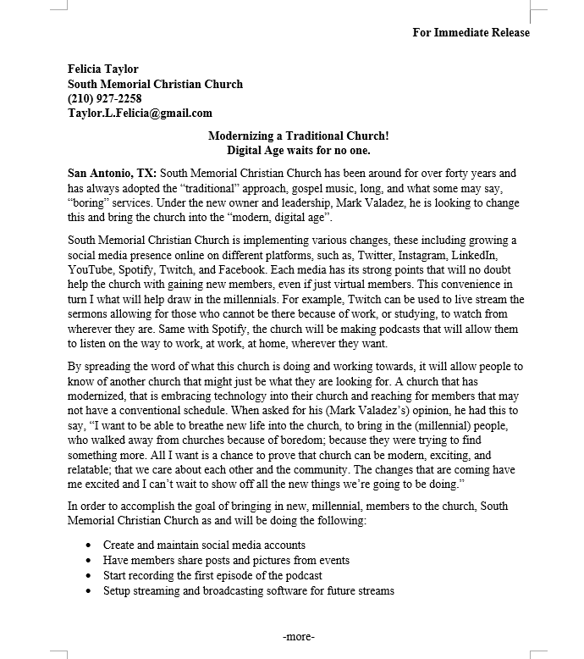Press Releases

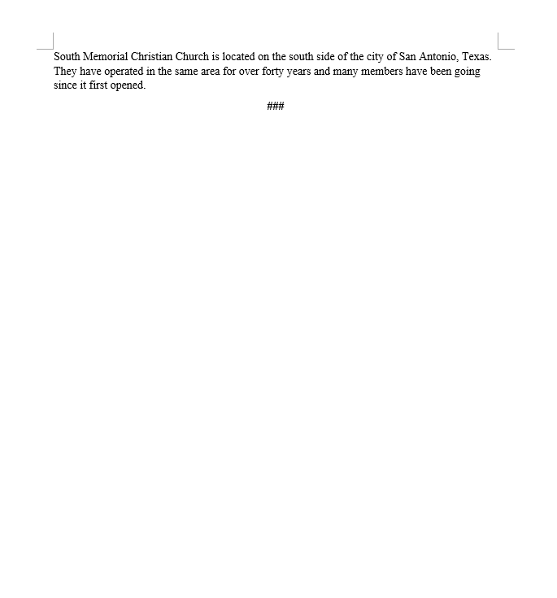

Appendix B:

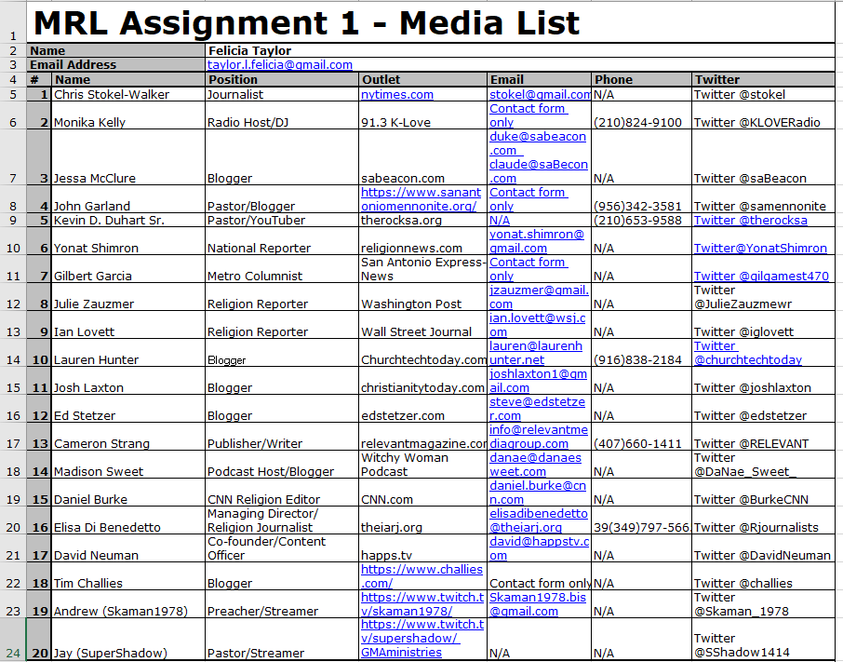Media List

Appendix C:

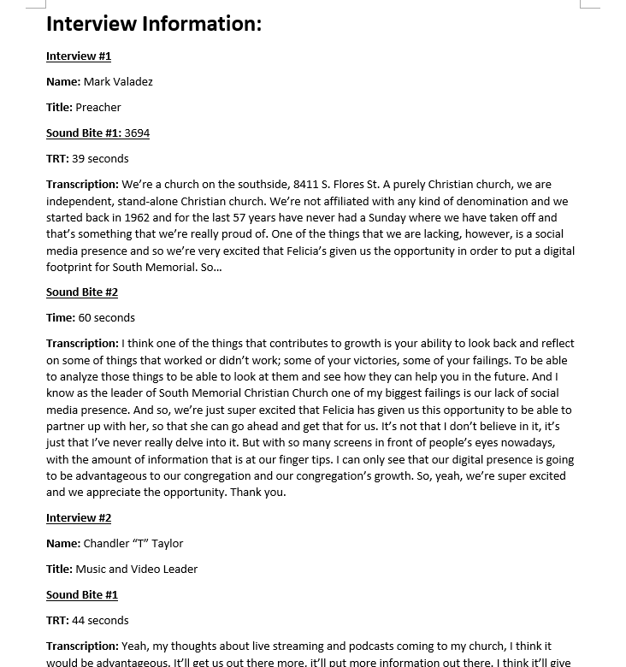Media Kit

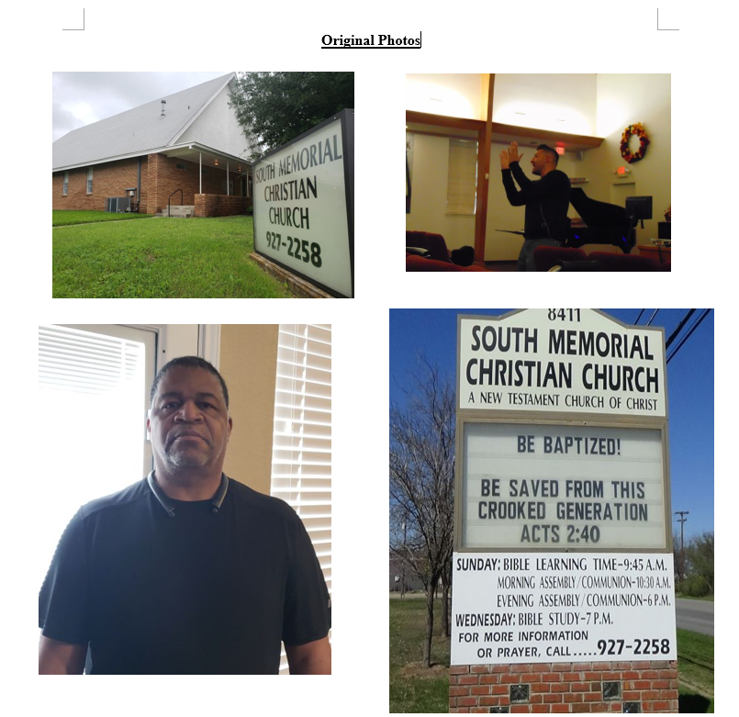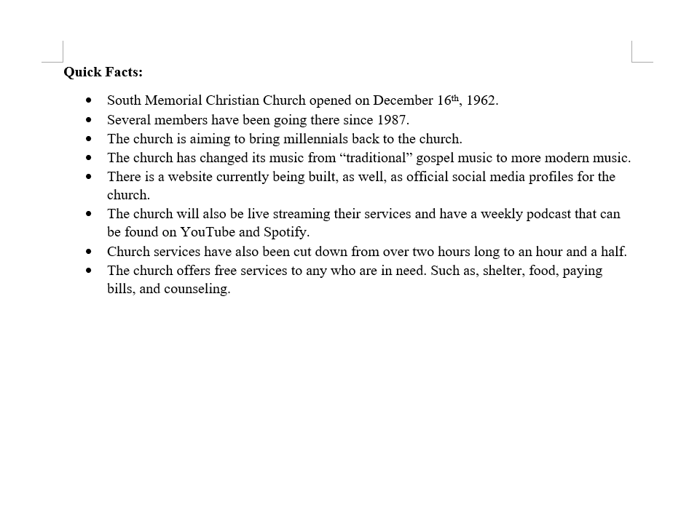

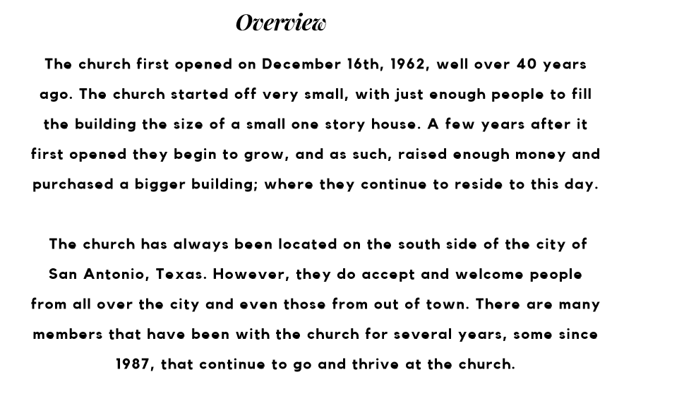

Appendix D:

Infographics

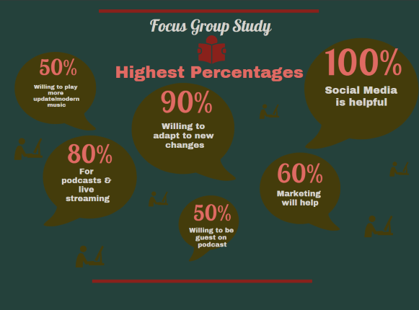

1: Research Plan, Primary Research Results section. Church Focus Group Study

Appendix E:

Twitter Account Analytics

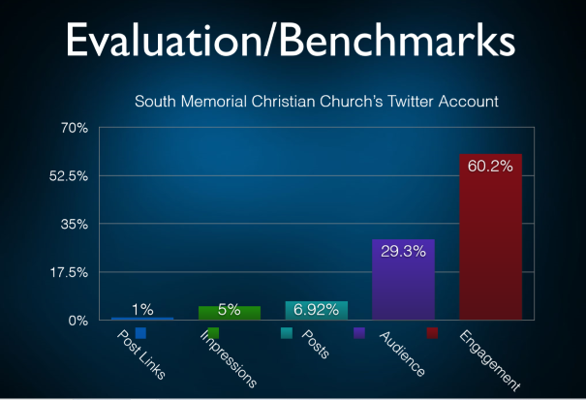

Campaign Plan: Campaign Results.

Looking at the graph above the analytics are from the date range: March 12 to June 10. Post links are at 1% with only two people clicking on any links on the church’s post. Impressions are at 5% with 500 users seeing the posts. The posts themselves are at 6.92% with a total of 103 published posts. The audience stands at 29.3% with the majority being between the ages of 25-34 which is the church’s target audience. Lastly, the engagement is the highest at 60.2%, with 200 followers, 300 people total who have engaged with the tweets, including sharing, retweeting, likes, and replies.

Appendix F:

Event Flyer

